**EXPORTING THE ANALYTICS**

|  |  |
| --- | --- |
| TEAM ID | PNT2022TMID41233 |
| PROJECT NAME | ESTIMATE THE CROP YIELD USING  DATA ANALYTICS |

Exporting The Analytics:

* Login to IBM Cognos then in open menu

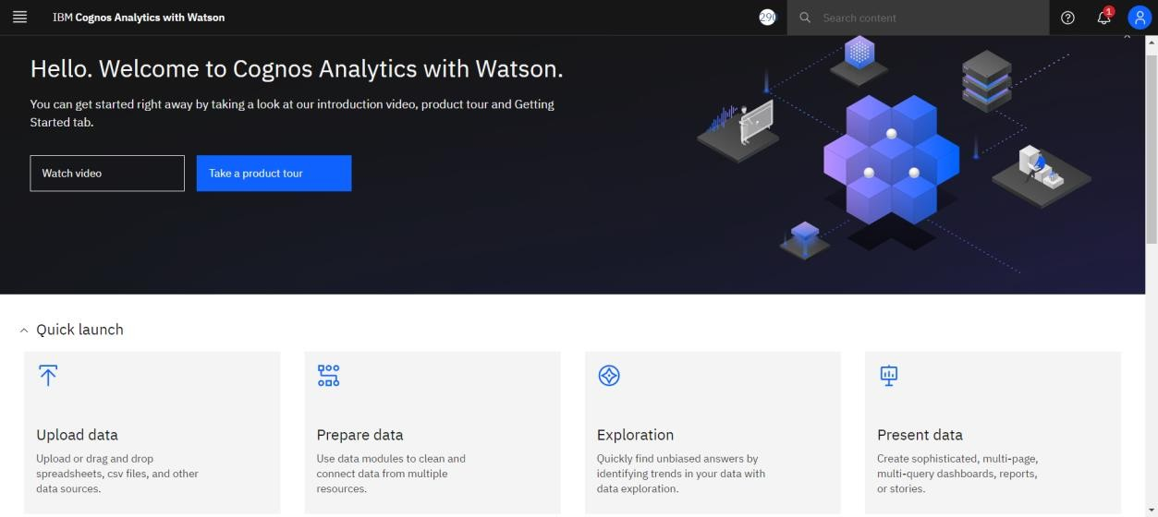

* Click on the share icon



* You can share using Email or Link or Export as pdf.

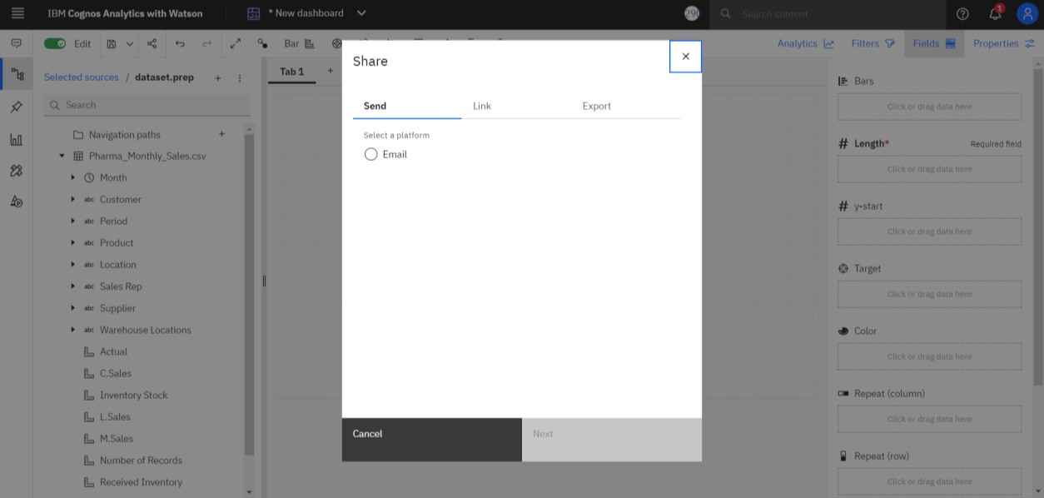

* Click the Export tab in the Share dialog box.
* You can change the page size and Orientation setting then click Export.

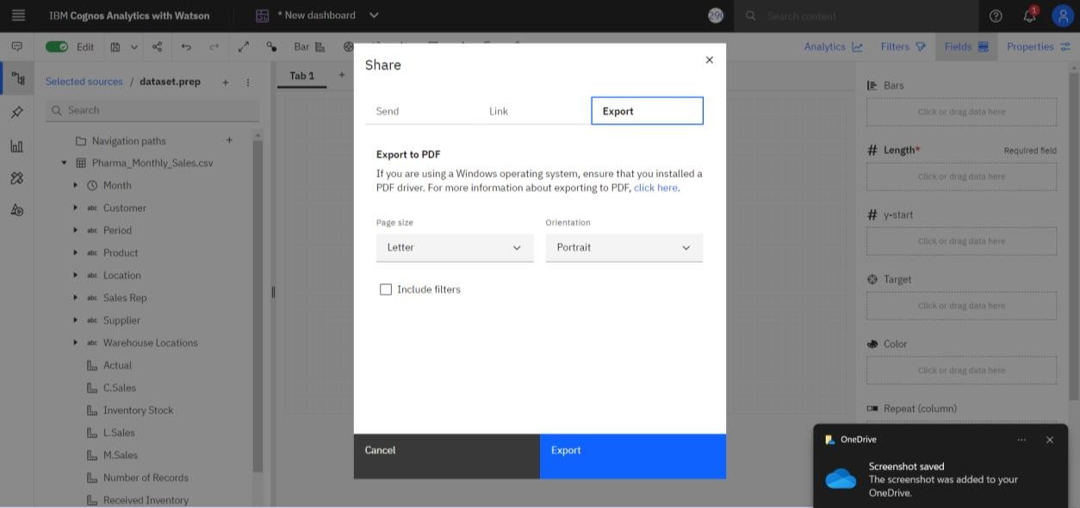

* + You can download here.

